
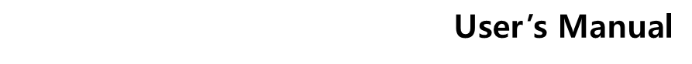
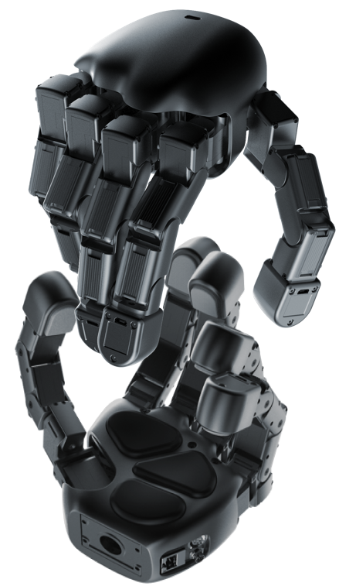



Allegro Hand V6 V User’s Manual
Copyright © WONIK ROBOTICS

Copyright & Trademark Notice
Allegro, the Allegro logo and all related files and documentation are Copyright by WONIK ROBOTICS. All rights reserved.

Allegro, Allegro Hand is trademarks of WONIK ROBOTICS. All other trademarks or registered trademarks are the property of their respective owners.

Contents
Copyright & Trademark Notice i
1. In the Box 1
2. Allegro Hand Overview 2
3. Technical Specifications 3
4. System Requirement 5
5. Joint Dimensions 6
6. Joint Directions 7
6.1 Right Hand 7
6.2 Left Hand 7
7. Mounting the Allegro Hand 8
7.1 Mounting Block Removal 8
7.2 Mounting 8
7.3 Reassembly 9
7.4 Mounting Block Dimensions 10
8. Allegro Hand Wiring 11
8.1 Wiring 11
8.2 Power 13
8.3 Tactile Sensor 14
9. Modbus Protocol 14
9.1 General Information 14
9.1.1 RS-485 Baud-Rate 14
9.1.2 Default Modbus-TCP Network Configurations 14
9.2 Supported Modbus Function Codes 15
9.3 Modbus Register Map (Holding Register) 16
9.3.1 Read-Only (RO) Telemetry Block 16
9.3.2 Read-Write (RW) Control & Configuration Block 17
9.3.3 Coil Map (Digital Control Flags) 20
9.3.4 FC23 Fast Loop Operation Guide 21
9.3.4.1 FC23 Request Parameter Specifications 21
9.3.4.2 Transaction Flow & Execution Order 21
9.3.4.3 Implementation Recommendations for Host Developers 22
9.3.5 joint_status Bit Mask Configuration 22
9.3.6 Finger & Pressure Sensor 22
9.3.7 IMU Config & IMU Data 24
9.3.7.1 Sensor Operating Modes 24
9.3.7.2 Unit Scales 26
9.3.8 Position Calibration 26
9.3.9 Grasp Position Storage & Playback 26
10. Technical Support 28
11. FAQ 29
11.1 Hardware FAQ 29
11.2 Software FAQ 33
Release Note 34

1. In the Box
Included are the software and hardware necessary to get you started.
- Allegro Hand 1 EA
- Allegro Hand Case 1 EA
- Power and Communication Cable (8 pin) 1 EA
- AC/DC Power Adapter 1 EA
- USB C Cable 1 EA
- Mounting Quick Changer 1 EA
- Assembly Kit
  - M4 x 8mm 4 EA
  - M6 x 10mm 4 EA
  - 3mm Allen Wrench 1 EA
  - 5mm Allen Wrench 1 EA

2. Allegro Hand Overview
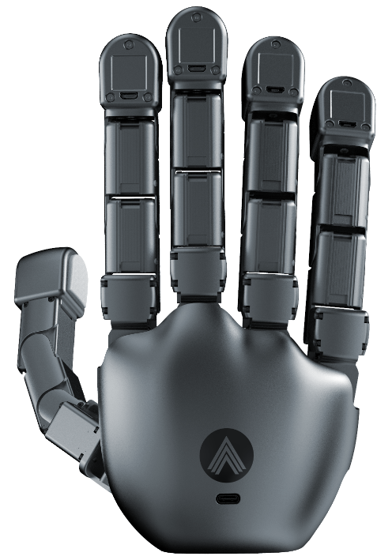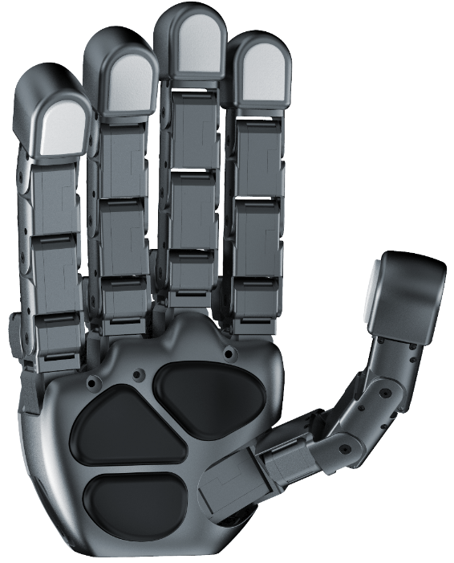
Allegro Hand is a highly adaptive robotic hand.
With five fingers and twenty independent current-controlled joints and tactile sensors, it’s the perfect platform for grasp and manipulation research.

Features
- Lightweight and portable anthropomorphic design
- Provides adduction and abduction capability of the fingers, enabling more natural and versatile grasping similar to a human hand
- Multiple ready-to-use grasping algorithms capable of handling a variety of object geometries
- 20 independent current-controlled joints (5 fingers x 4 DOF ea.)
- Equipped with 5 vision sensing channels (5 fingertips) and 3 pressure sensing channels (3 palm) to capture detailed force distribution for precise tactile feedback
- Support for real-time control and online simulation
3. Technical Specifications
Number of Fingers | 4 fingers + 1 thumb = 5
Degrees of Freedom | 5 fingers x 4 = 20 (active)
Actuation | Type | DC motor
Actuation | Gear Ratio | 288.35:1
Actuation | Stall Torque | 0.92 Nm
Actuation | Nominal Torque | 0.23 Nm
Payload | Max. 15kg
Weight | 1,150g
Joint Resolution | 0.088 deg
Communication | Interface | RS-485, Ethernet
Communication | Protocol | Modbus (RTU, TCP), RS-485 Custom
Communication | Tactile Sensor | USB Type-C - USB 2.0 High-Speed  *The tactile sensor Independent from RS-485/Ethernet.
Power Requirement | 24.0 V / 5.0 A / 120 W
Tactile Sensor | Sensor Type | Vision-based Tactile Sensor
*Vision Sensor (Gelsight) | Sensor Type | Vision-based Tactile Sensor
 | Image Stream | VGA: 640 × 480 @ 15 / 30 fps  QVGA: 320 × 240 @ 30 / 60 fps
 | Output | Color Tactile Image (Contact Geometry)
 | Interface | USB 2.0
 | Device Identification | Unique Serial Number
Palm Sensor | Pressure Operating Range | 260 to 1260 hPa  (Atmospheric pressure is 1,013.25 hPa)
*Pressure Sensor | Pressure Operating Range | 260 to 1260 hPa  (Atmospheric pressure is 1,013.25 hPa)
 | Temperature Operating Range | 0~60 ℃
 | Pressure Accuracy | 1 hPa

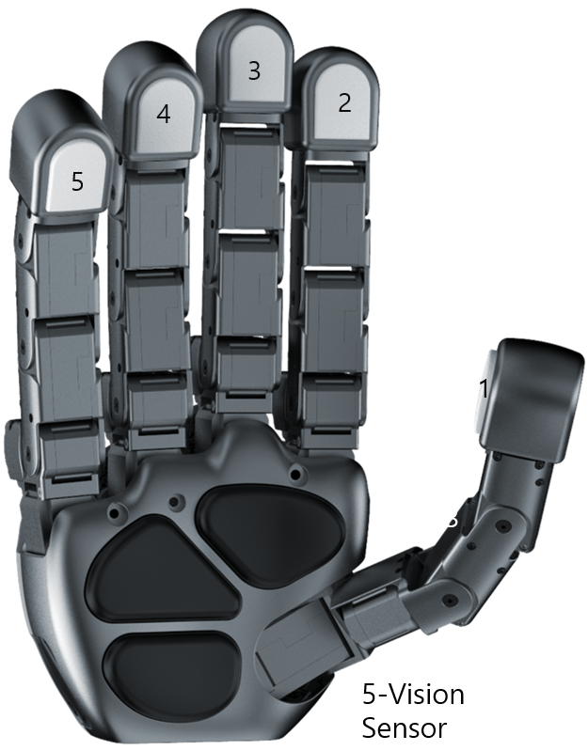
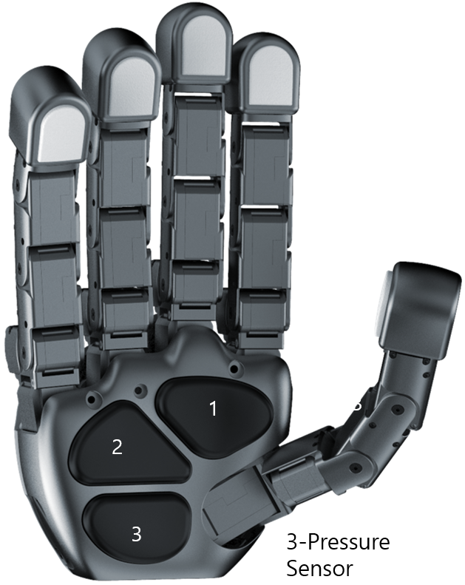
4. System Requirement
CPU | Intel® CoreTM i3-8109U or higher
RAM | at least 2GB
Storage | at least 2GB
Graphics | OpenGL 3.0 H/W Acceleration enabled with at least 64Mb of video RAM
OS | Ubuntu® 22.04 LTS & 24.04 LTS
Additional S/W | ROS2

5. Joint Dimensions
All dimensions are displayed in millimeters (mm) and degrees.

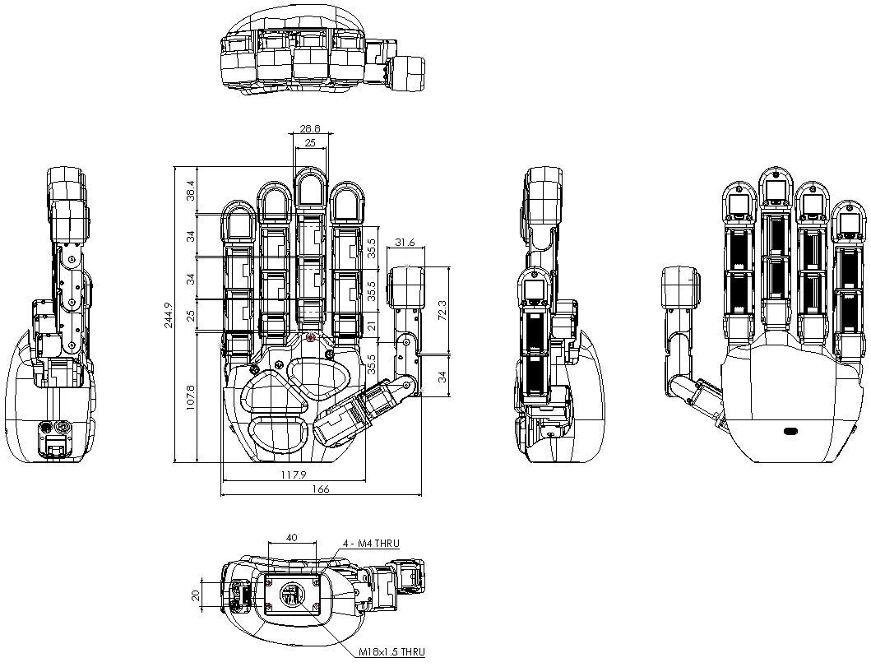
6. Joint Directions
6.1 Right Hand
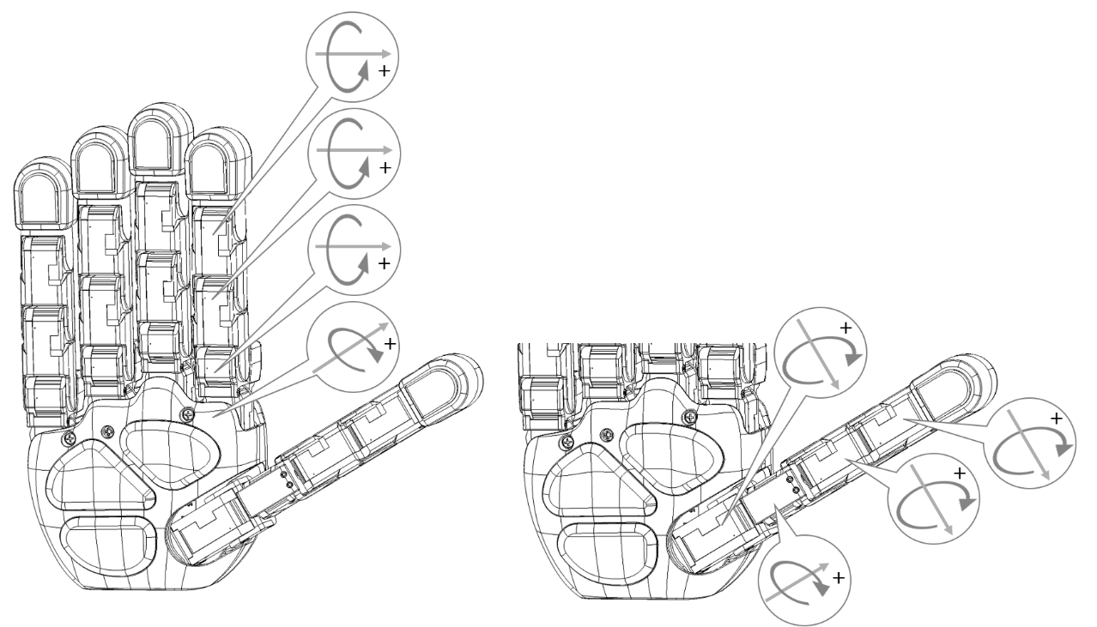

6.2 Left Hand
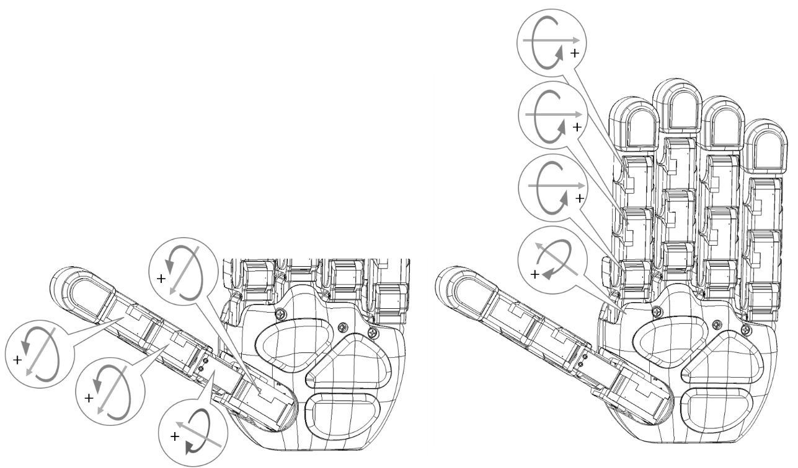
7. Mounting the Allegro Hand
All dimensions are displayed in millimeters (mm) and degrees.

7.1 Mounting Block Removal
The mounting block is connected to the Allegro Hand using four M4x6mm hex socket head cap screws. Once the 4 screws have been removed, the mounting block can be removed from the bottom of the hand

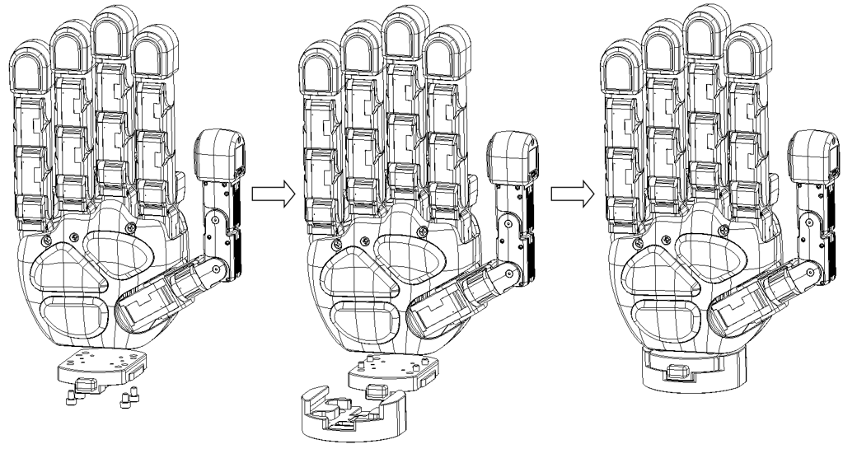

7.2 Mounting
The block can be mounted to the manipulator's end effector using four M6x10mm hex socket head cap screws.
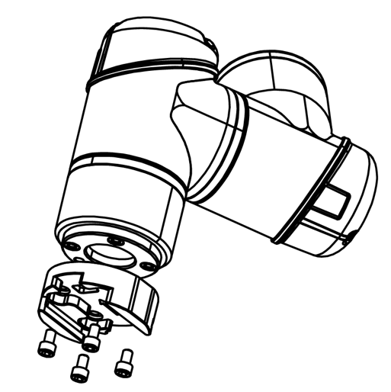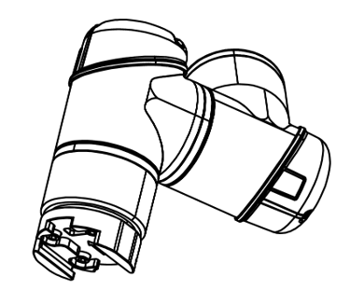

When changing the hand's orientation, please use a alternator bracket; please follow the instructions below.

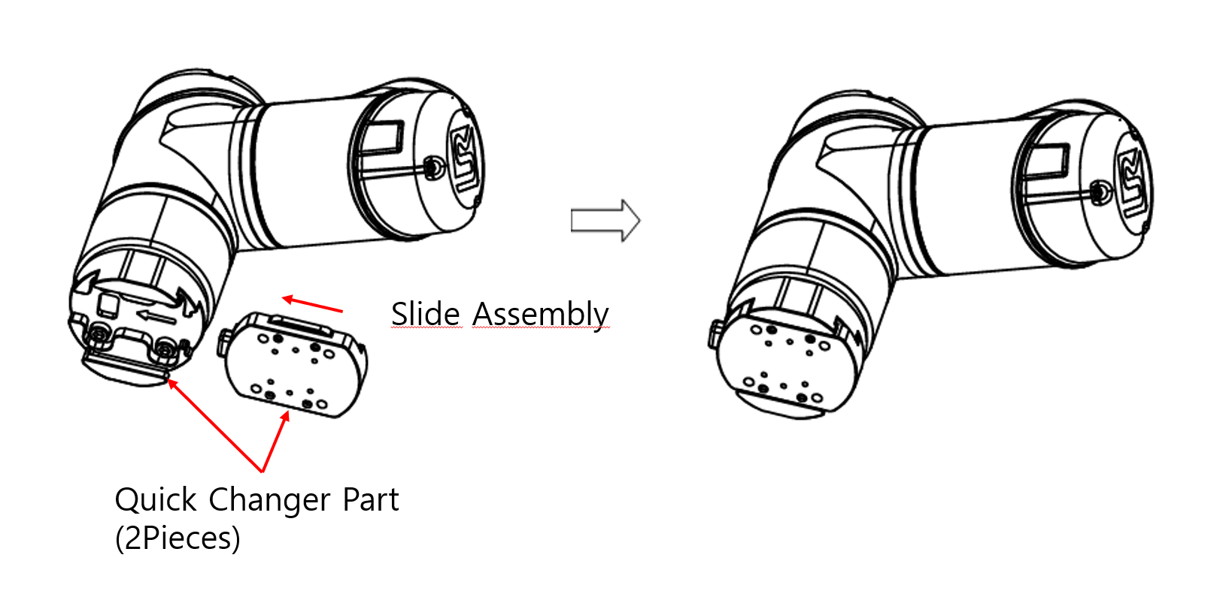

7.3 Reassembly
Place the hand onto the mounting block and replace the three M4x10mm hex socket head cap screws.
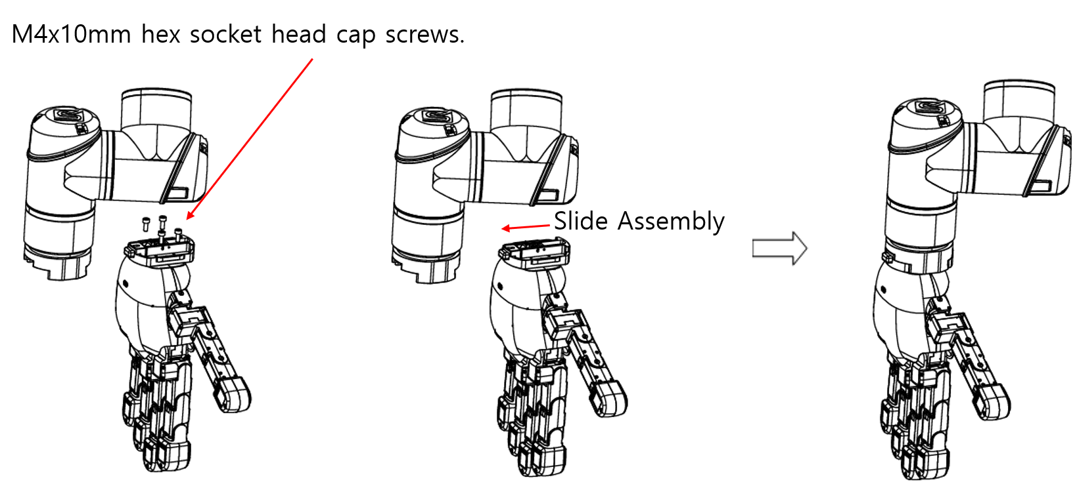

7.4 Mounting Block Dimensions
The relevant dimensions of the mounting block are presented in millimeters (mm).
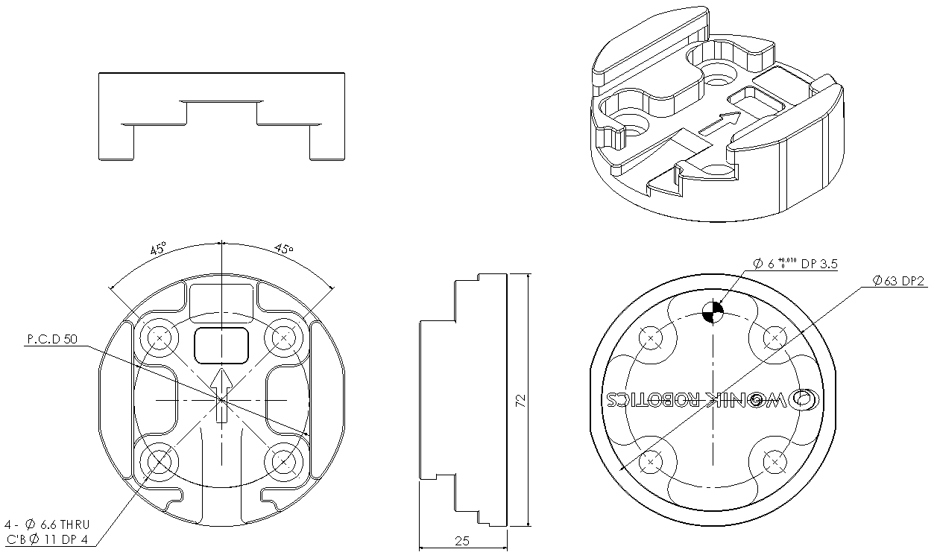

8. Allegro Hand Wiring
8.1 Wiring
On the back of the Allegro Hand, you will see a connector. This connector is used to supply power to hand. It also has external interface. Connector used is
CDM810-08A-MW-F810-050-67 part.
 | Part Name | Note
Panel Mount Connector | CDM810-08A-MW-F810-050-67 | M8 Stecker 8P, A-coding
Cable Connector | CDM818-08A-01FRA-2M-67 | M8-F-Angle-8P-3m

Connector Pinout
No. | Description | Wiring Color
1 | RS485- | White
2 | RS485+ | Brown
3 | 24VDC_IN | Green
4 | GND | Yellow
5 | 24VDC_IN | Gray
6 | GND | Pink
7 | 24VDC_IN | Blue
8 | GND | Red

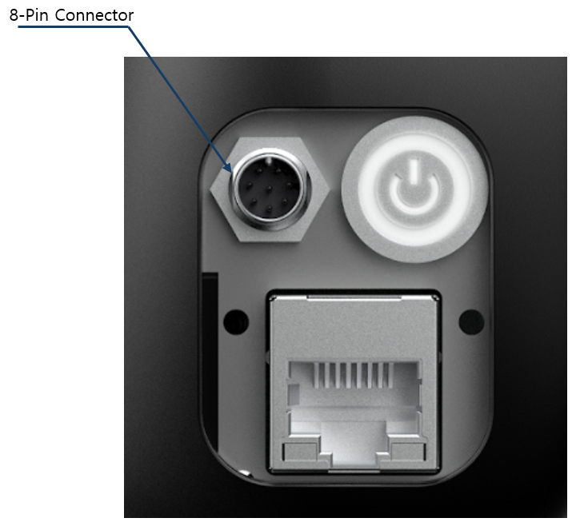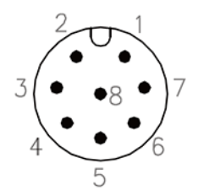

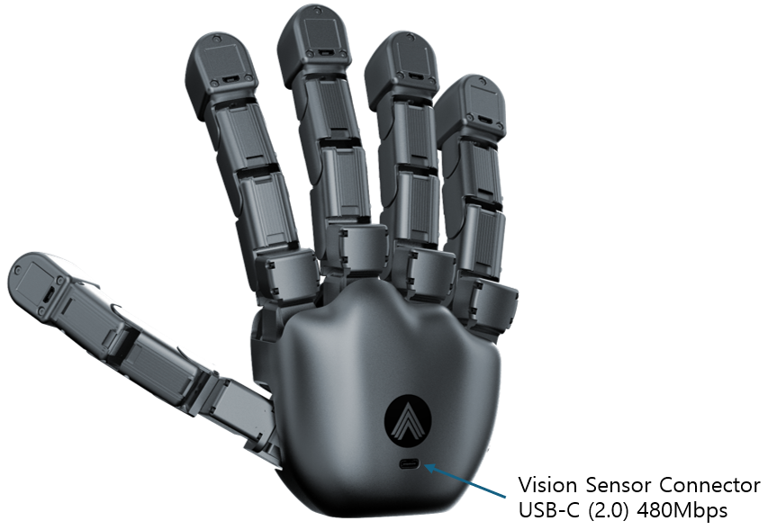
8.2 Power
The Allegro Hand must be powered by DC 24V, 5A power supply. If a capacity of power supply is not sufficient, it will not work properly.
Once the power is supplied at the rated values, the power switch on the back of the Allegro Hand can be switched on to provide power to the hand.

8.3 Tactile Sensor
The five tactile sensors are connected to the host PC through the USB Type-C connector using USB 2.0 High-Speed communication.
DIGIT sensor communication is independent from the Allegro Hand RS-485 and Ethernet interfaces. The USB Type-C cable is used only for the tactile vision sensors.

9. Modbus Protocol

9.1 General Information
9.1.1 RS-485 Baud-Rate
Modbus RTU (RS-485) requires a baud rate of 2 Mbps or higher.
The default baud rate for RS-485 is set to 2 Mbps.

9.1.2 Default Modbus-TCP Network Configurations
The default network configurations for the Allegro Hand to use Modbus TCP are as follows:
- Default IP Address: 192.168.1.100
- Default GW Address: 192.168.1.1
- Default Subnet Mask: 255.255.255.0
- Port: 502
[NOTE]
- The last byte (octet) of the MAC address is linked with the Slave ID.
- To apply the changes properly, please reboot the hand (device) after configuration. The previous settings will remain active until a reboot is performed.

9.2 Supported Modbus Function Codes
Function Code | Name | Target Area | Remarks
FC01 (0x01) | Read Coils | Coil Map (0x0000 ~ 0x0010) | Reads single/multiple coil status
FC03 (0x03) | Read Holding Registers | Register Map (0x0000 ~ 0x0310) | Reads single/multiple consecutive registers
FC05 (0x05) | Write Single Coil | Coil Map (0x0000 ~ 0x0001) | Controls a single coil  (Factory-set items are write-protected)
FC15 (0x0F) | Write Multiple Coils | Coil Map (0x0000 ~ 0x0001) | Controls multiple coils
FC16 (0x10) | Write Multiple Registers | RW Register Block | Controls multiple registers
FC23 (0x17) | Read/Write Multiple Registers | RO & RW Register Block | Simultaneous write and read in a single packet

9.3 Modbus Register Map (Holding Register)
9.3.1 Read-Only (RO) Telemetry Block
• Supported Function Codes: FC03, FC23 (Fast Loop Feedback Reading)
• Description: Continuous reading range for sensor and system status data
• Address Ranges & Registers:
- Slow Loop Read: 0x0000 ~ 0x0066 (Total 103 Registers)
- Fast Loop Read: 0x0000 ~ 0x003D (Total 62 Registers)

Address (HEX) | Item Name | Data Type | Regs | Unit / Range | Description / Remarks
0x0000 | f_pos[20] | int16_t | 20 | Raw | Fast Loop Joint Position (FC23/FC03)
0x0014 | f_curr[20] | int16_t | 20 | Raw | Fast Loop Joint Current/Torque (FC23/FC03)
0x0028 | imu_data[4] | int16_t | 4 | Raw | BNO055 IMU Data (Quaternion/Euler)
0x002C | hpa[18] | uint16_t | 18 | hPa | Pressure sensors (5 fingers + palm)
0x003E | Reserved | - | 2 | - | Padding
0x0040 | f_temp[20] | uint16_t | 20 | ℃ | Motor Temperature (4 joints per finger)
0x0054 | s_temp[18] | uint16_t | 18 | 100 LSB/℃ | Pressure Sensor Temperature
0x0066 | joint_status | uint16_t | 1 | Bitmask | Joint Status (Fault, Limit, Error, etc.)
0x0067 | Reserved | - | 9 | - | -
0x0070 | fw_ver | uint16_t | 1 | Hex | Firmware Version (e.g., 0x0100 = v1.0)
0x0071 | hand_type | uint16_t | 1 | Enum | 0: Left Hand, 1: Right Hand

9.3.2 Read-Write (RW) Control & Configuration Block
• Supported Function Codes: FC03, FC16, FC23 (Fast Loop Control Writing)
• Description: Continuous writing and command control range for Fast Loop

[Fast Control Block]
Address (HEX) | Item Name | Data Type | Regs | Supported FC | Description / Remarks
0x0100 | goal_pos[20] | int16_t | 20 | FC23, FC16, FC03 | Fast Loop target position command (pulse)
0x0114 | goal_curr[20] | int16_t | 20 | FC23, FC16, FC03 | Fast Loop target current command (mA)
0x0128 | op_mode | uint16_t | 1 | FC03, FC16 | Joint Operating Mode (0: Current, 5: Pos)  Default: 5, Real-time only (not saved to Flash)
0x0129 | grasp_save_slot | uint16_t | 1 | FC03, FC16 | Grasp position save trigger (1~5)  Saves current position
0x012A | grasp_play_slot | uint16_t | 1 | FC03, FC16 | Grasp position playback trigger (1~5)  Sets goal_pos to saved position

[Gain & Profile Config Block]
Address (HEX) | Item Name | Data Type | Regs | Supported FC | Description / Remarks
0x0200 | gain_kp[20] | uint16_t | 20 | FC03, FC16 | Joint P Gain
0x0214 | gain_ki[20] | uint16_t | 20 | FC03, FC16 | Joint I Gain
0x0228 | gain_kd[20] | uint16_t | 20 | FC03, FC16 | Joint D Gain
0x023C | prof_vel[20] | uint32_t | 40 | FC03, FC16 | Velocity Profile (2 Regs per joint)
0x0264 | prof_acc[20] | uint32_t | 40 | FC03, FC16 | Acceleration Profile (2 Regs per joint)

[System & Network Config Block]
Address (HEX) | Item Name | Data Type | Regs | Supported FC | Description / Remarks
0x0300 | comm_sel | uint16_t | 1 | FC03 | RS485 Comm Mode (RO)  (1: Modbus, 0: Custom)
0x0301 | slave_id | uint16_t | 1 | FC03, 16 | Modbus Slave ID (1 ~ 247)
0x0302 | imu_config | uint16_t | 1 | FC03, 16 | BNO055 IMU Op Mode
0x0303 | Reserved_0 | uint16_t | 1 | FC03, 16 | RS485 Baudrate Config
0x0304 | Reserved_1 | uint16_t | 1 | FC03, 16 | (TBD) Development Option
0x0305 | Reserved | - | 11 | - | Padding
0x0310 | net_ip | uint32_t | 2 | FC03, 16 | IPv4 Address
0x0312 | net_mask | uint32_t | 2 | FC03, 16 | Subnet Mask
0x0314 | net_gw | uint32_t | 2 | FC03, 16 | Gateway Address
0x0316 | net_dns | uint32_t | 2 | FC03, 16 | DNS Address
0x0318 | serial_no | uint64_t | 4 | FC03 | Serial Number
※ The comm_sel setting can be changed via the comm_sel pins on the switch block of the Allegro Hand's internal control board. By default, this is set to Modbus.
[CAUTION]
- When network settings (IP address, Subnet Mask, Gateway, DNS) or major communication parameters are modified, the new values are saved to the flash memory.
- To apply the changes properly, please reboot the hand (device) after configuration. The previous settings will remain active until a reboot is performed.

9.3.3 Coil Map (Digital Control Flags)
• Supported Function Codes: FC01 (Read Coil), FC05 (Write Single Coil), FC15 (Write Multiple Coils)
Address (HEX) | Item Name | Data Type | Supported FC | Description / Remarks
0x0000 | torque_enable | Bool | FC01, 05, 15 | Servo Torque On/Off (0: OFF, 1: ON)
0x0001 | joint_calib | Bool | FC01, 05, 15 | Joint Calibration Start (0: Idle, 1: Start)
※ For detailed information, refer to 9.3.8 Position Calibration.
9.3.4 FC23 Fast Loop Operation Guide

The FC23 (Read/Write Multiple Registers) function code is specifically designed for high-performance Fast Control Loops. It allows the host PC (Master) to update target commands and retrieve real-time sensor/state feedback within a single communication cycle, significantly reducing latency compared to running separate write and read commands.

9.3.4.1 FC23 Request Parameter Specifications
When configuring an FC23 request packet from the Master to the Allegro Hand, use the following parameters:
- Read Starting Address: 0x0000 (Points to f_pos)
- Read Quantity: 40 Registers (f_pos [20 regs] + f_curr [20 regs])
- Write Starting Address: 0x0100 (Points to goal_pos)
- Write Quantity: 40 Registers (goal_pos [20 regs] + goal_curr [20 regs])
- Write Byte Count: 80 Bytes (40 registers $\times$ 2 bytes)

9.3.4.2 Transaction Flow & Execution Order

Single RTT (Round Trip Time) Exchange
A single packet transmission from the host PC updates goal_pos and goal_curr while simultaneously retrieving the latest joint positions (f_pos) and currents/torques (f_curr). This cuts communication latency by more than half compared to sequential FC16 (Write) and FC03 (Read) operations.

Allegro Hand Internal Execution Sequence
To maintain deterministic control performance, the Allegro Hand Modbus receive ISR/Task processes the packet in a strict internal sequence:
- Write Processing First: The Allegro Hand immediately updates the internal target command registers (goal_pos and goal_curr) with the values provided in the request packet.
- Read Processing Follows: Immediately after updating the targets, the Allegro Hand captures the latest sensor states and joint feedback.
- Response Transmission: The Allegro Hand packages the feedback data into the response frame and sends it back to the host PC.

9.3.4.3 Implementation Recommendations for Host Developers
- Control Loop Timing: Design the host control loop to match or exceed the Allegro Hand target cycle to fully leverage the speed benefits of FC23.
- Data Types: Ensure that goal_pos, goal_curr, f_pos, and f_curr are handled as signed 16-bit integers (int16_t) in a contiguous memory block to prevent misalignment errors during packing and unpacking.

9.3.5 joint_status Bit Mask Configuration
Bit Range | Name | Description
Bit 0 ~ 3 | HW_INT_ERR | Hardware Integration Error (Overload, Shock, Overheat, or Voltage).  Triggered if any joint encounters an error.
Bit 4 | F0_COMM_ERR | Finger 0 Communication Error (ID match/timeout failure)
Bit 5 | F1_COMM_ERR | Finger 1 Communication Error (ID match/timeout failure)
Bit 6 | F2_COMM_ERR | Finger 2 Communication Error (ID match/timeout failure)
Bit 7 | F3_COMM_ERR | Finger 3 Communication Error (ID match/timeout failure)
Bit 8 | F4_COMM_ERR | Finger 4 Communication Error (ID match/timeout failure)
Bit 9 | F0_FAULT | Finger 0 Internal Fault Status
Bit 10 | F1_FAULT | Finger 1 Internal Fault Status
Bit 11 | F2_FAULT | Finger 2 Internal Fault Status
Bit 12 | F3_FAULT | Finger 3 Internal Fault Status
Bit 13 | F4_FAULT | Finger 4 Internal Fault Status
Bit 14 ~ 15 | Reserved | Reserved for future expansion (Maintain as 0)

9.3.6 Finger & Pressure Sensor
Finger Index Reference
Finger Index | Finger Name | Description
0 | Thumb (F0) | Thumb finger joints
1 | Index (F1) | Index finger joints
2 | Middle (F2) | Middle finger joints
3 | Ring (F3) | Ring finger joints
4 | Little (F4) | Little (Pinky) finger joints

Pressure Sensor Index Reference
For the pressure sensor array (hpa[3]), Palm is equipped with 3 sensors,
indexed sequentially starting from the top of the palm to the bottom.
Sensor Index | Palm Position | Description
0 | Upper Palm | Upper pressure sensing area of the palm
1 | Middle Palm | Middle pressure sensing area of the palm
2 | Lower Palm | Lower pressure sensing area of the palm
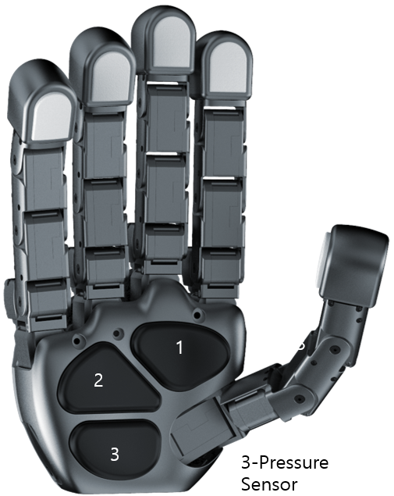

9.3.7 IMU Config & IMU Data
The Allegro Hand V6 is equipped with a BNO055 IMU sensor and supports the following configurations:

9.3.7.1 Sensor Operating Modes
The BNO055 sensor supports Raw Data modes, which output raw sensor measurements, and Sensor Fusion modes, which calculate 3D orientation via internal algorithms. The output data format follows the imu_data array specifications.

Raw Data Modes
Outputs physical sensor measurements directly without post-processing.
- 0x00 IMU Disable: Disables the IMU sensor (Factory Default)
- 0x01 ACCONLY: Outputs raw acceleration values ([accel_x, accel_y, accel_z, 0])
- 0x02 MAGONLY: Outputs raw geomagnetic (magnetometer) values ([mag_x, mag_y, mag_z, 0])
- 0x03 GYROONLY: Outputs raw gyroscope values ([gyro_x, gyro_y, gyro_z, 0])

Sensor Fusion Modes
Outputs 3D spatial orientation in quaternion format ([w, x, y, z]) through internal fusion algorithms.
- 0x08 IMU: Accelerometer and gyroscope fusion (magnetometer unused, relative orientation)
- 0x09 COMPASS: Heading fusion including magnetometer
- 0x0A M4G: Magnetically-based fusion
- 0x0B NDOF_FMC_OFF: 9-axis full fusion (fast magnetometer calibration feature disabled)
- 0x0C NDOF: 9-axis full fusion (absolute orientation measurement)

9.3.7.2 Unit Scales
The default output data resolution and scale standards for the BNO055 sensor are as follows:
Data Type | Symbol / Name | Scale & Unit | Description
Acceleration (Raw) | RAW_ACCEL | 1 LSB = 1 mg | Accelerometer raw data scale
Magnetometer (Raw) | RAW_MAG | 1 LSB = 1/16 µT | Magnetometer raw data scale
Gyroscope (Raw) | RAW_GYRO | 1 LSB = 1/16 dps | Gyroscope raw data scale (Degrees Per Second)
Orientation (Quaternion) | QUATERNION | 1 LSB = 1/16384 | Fusion mode output quaternion scale (dimensionless)

9.3.8 Position Calibration
To set the current position as the origin (Home position), perform the following steps:
- Prerequisites: Ensure that the torque_enable register (Coil Address 0x0000) is set to 0 (OFF).
- Trigger Calibration: Set the joint_calib register (Address 0x0001) to 1 (ON).
- Finish Calibration: Set the joint_calib register (Address 0x0001) back to 0 (OFF).
- Verification: Monitor the f_pos register. Calibration is successfully completed when the value of f_pos changes to 0.
Warning: Ensure that the robotic hand is in the desired home position before initiating calibration, as this process overwrites the origin offset.

9.3.9 Grasp Position Storage & Playback

Grasp Position Storage & Playback (Slots 1~5)
Users can store and retrieve up to 5 custom grasp positions. Position data saved in these slots is stored in the Allegro Hand's internal Flash memory (Non-volatile).
- Saving a Grasp Position:
  - Manually adjust the Allegro Hand fingers to the desired grasp position.
  - Write the desired slot number (1~5) to the grasp_save_slot register.
  - The Allegro Hand captures and stores the current joint positions into the selected Flash memory slot.

Important Note: Saving to the internal Flash memory requires a few seconds. Please ensure that no other communication commands are sent to the hand while the write process is in progress to prevent data corruption or save failures.

- Playing a Grasp Position:
  - Write the desired slot number (1~5) to the grasp_play_slot register.
  - The Allegro Hand sets the goal_pos to the saved position and executes the grasp motion.

- Execution Conditions: To successfully perform the grasp motion, the following conditions must be met:
  - Operating Mode: Set to Pos Control mode.
  - Torque Status: torque_enable must be set to ON.
  - Goal Current: goal_curr must be set to a valid value.

10. Technical Support
The newest version of all documents found in this manual can be found in the Allegro Hand website at
https://www.allegrohand.com/
A forum is also available on the website where users can share problems and solutions with each other and with WONIK ROBOTICS.
For any further questions please contact us.
Address | Wonik Bldg. 4F, 20, Pangyo-ro 255beon-gil, Bundang-gu, Seongnam-si, Gyeonggi-do, Republic of Korea
Phone | +82-31-8038-9180
Fax | +82-31-8038-9190
Email | robotics.biz@wonik.com

11. FAQ
11.1 Hardware FAQ
- CAD STL Files
If you purchase, we will provide STL files.
Please give us your Hand’s serial number.

- Communication interface
Modbus (RTU, TCP), RS-485 Custom communication is supported.

- Tactile sensor
The contact surface of the tactile sensor is made of a soft elastomer, and it operates by capturing deformation of the surface with an internal camera and illumination system.
If the elastomer surface is scratched, cut, or punctured by sharp objects such as an awl, needle, or knife, the sensor may be damaged or may not operate properly.

- How robust is it to collisions?
Difficult to use in harsh environments.
It should be noted that this is for research purposes only.
Please avoid hitting a hammer or applying any excessive force.

- Range of motion

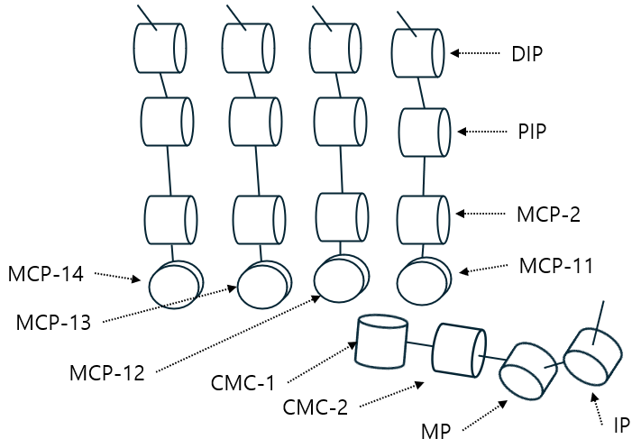

 | Joint | ROM [deg]
Finger | MCP-11 | -22 ~ 75
Finger | MCP-12 | -65 ~ 65
Finger | MCP-13 | -75 ~ 22
Finger | MCP-14 | -75 ~ 25
Finger | MCP-2 | -4 ~ 90
Finger | PIP | -10 ~ 80
Finger | DIP | -10 ~ 80
Thumb | CMC-1 | -2~ 95
Thumb | CMC-2 | -95 ~ 95
Thumb | MP | -10 ~ 75
Thumb | IP | -10 ~ 80

11.2 Software FAQ
- Is it possible to use V4, V5_Plus or V5_Sense software?
No.
There are many differences between V6 and previous versions.

- How to set (left or right) of hand in SW?
Software automatically applies to the appropriate handedness and hand type through the serial number. Therefore, you can simply use it as is.

- Where can PC S/W issues be supported?
You can use our official Forum: https://www.allegrohand.com/forum
Or you can check our official GitHub latest release, see the link below.
https://github.com/Wonikrobotics-git

Release Note
Date | Ver. | Description | Editor
2026.10.01 | 1.0 | Initial draft | BK Lee
2026.10.29 | 1.1 | Add hand drawing dimensions | SH Yang
2026.10.30 | 1.1.1 | Change Port Number of Modbus | SH Yang*

